🔍 What is Support Vector Regression (SVR)?
  - 1.1.1.2 Support Vector Regression (SVR)

ε (epsilon) – Epsilon-Insensitive Tube
- Name: Epsilon (Greek letter)
- Meaning: Defines a margin of tolerance where no penalty is given.
- Role: The model does not care (i.e., is insensitive) to errors within ±ε range from the actual value.
- Also called: Epsilon-insensitive loss margin or epsilon-tube.
👉 Think of it as a "safe zone" — predictions within this margin are not penalized.

🔹 w – Weight Vector
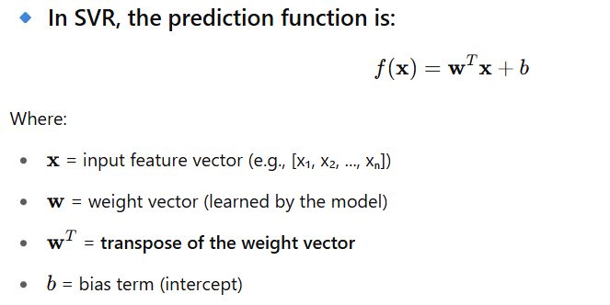
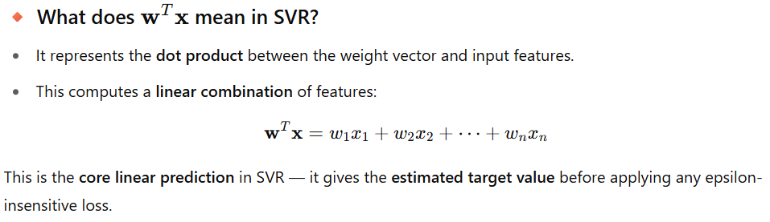
Why the transpose?
- Vectors w and x are typically column vectors.
- To compute the dot product, we need one to be a row vector — so we use the transpose of
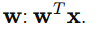
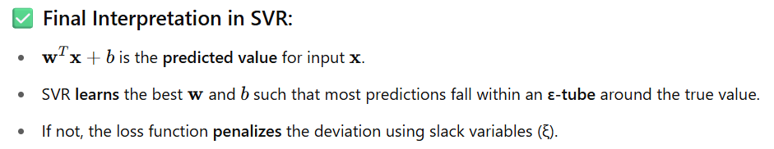

🔹 ξ and ξ* (xi and xi-star) – Slack Variables
- Name: Slack variables (Greek letter xi: ξ)
- Meaning: Measure how far the predictions are outside the epsilon margin.
- Role:
  - ξi : deviation above ε
  - ξ*​: deviation below -ε
- Also called: Loss variables, error distances, or constraint violations
👉 They represent how much a prediction violates the margin — these values are penalized during training.

Support Vector Regression (SVR) – A Deep Dive
✅ Category:
- Supervised Learning
- Regression Algorithm (predicts continuous values)
- Based on Support Vector Machines (SVM)

What is Support Vector Regression (SVR)?
SVR is a type of regression algorithm that tries to find a function that approximates the data within a certain acceptable error margin (ε).
Unlike linear regression that tries to minimize the total error (like MSE), SVR:
- Tries to fit the best hyperplane (or curve) within an ε-insensitive tube.
- Only penalizes predictions that fall outside this ε margin.
- Focuses on support vectors: the data points that lie on the edge or outside the ε-tube.
https://www.geeksforgeeks.org/support-vector-regression-svr-using-linear-and-non-linear-kernels-in-scikit-learn/

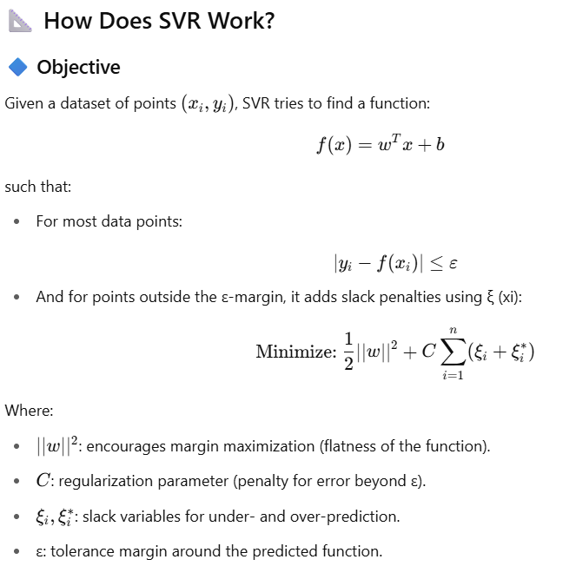

Graphical Intuition
- SVR creates a tube of width 2ε around the regression line.
- Points inside the tube are considered correctly predicted.
- Only the points outside the tube influence the model — these are the support vectors.

🧠 Key Concepts
Term | Meaning
Epsilon (ε) | ε-tube width: determines how much deviation from actual y is acceptable
Support Vectors | Data points that lie outside the ε margin
Kernel Trick | Maps input features into higher-dimensional space (for nonlinear regression)
Regularization (C) | Controls the trade-off between flatness and tolerance for outliers

🧮 Kernel Functions in SVR
SVR can perform both linear and non-linear regression using kernels.
Kernel Type | Description
Linear | Works well when data is linearly separable
Polynomial | Fits polynomial curves
RBF (Gaussian) | Popular for non-linear problems
Sigmoid | Behaves like a neural network

🎯 Use Cases of SVR
Domain | Application
Finance | Stock price forecasting
Healthcare | Predicting patient recovery time
Energy | Load forecasting in power grids
Engineering | Sensor signal estimation
Marketing | Forecasting ad campaign performance

⚙️ How SVR Works (Training Process)
- Choose a kernel (linear or nonlinear)
- Define the ε margin
- Use support vectors that fall outside the margin to define the model
- Optimize using Quadratic Programming to find the best fit with minimum deviation

📈 Assumptions of SVR
- Data may or may not be linearly separable (kernels help with nonlinear data)
- It can tolerate some outliers (controlled via C parameter)
- Works best with normalized or scaled data

Dataset: California Housing (predicting median house value)
# 📌 Step 1: Import Libraries
import numpy as np
import matplotlib.pyplot as plt
from sklearn.datasets import fetch_california_housing
from sklearn.svm import SVR
from sklearn.model_selection import train_test_split
from sklearn.preprocessing import StandardScaler
from sklearn.metrics import mean_squared_error, r2_score
from sklearn.pipeline import make_pipeline

# 📌 Step 2: Load Dataset
data = fetch_california_housing()
X = data.data # Features
y = data.target # Target: Median house value

# Let's take only 1 feature for visualization (e.g., average rooms per household)
X = X[:, [3]] # 'AveRooms'

# 📌 Step 3: Train/Test Split
X_train, X_test, y_train, y_test = train_test_split(X, y, test_size=0.2, random_state=42)

# 📌 Step 4: Define SVR Model Pipeline (with scaling)
svr_model = make_pipeline(
StandardScaler(), # Normalize data
SVR(kernel='rbf', C=100, epsilon=0.1) # RBF kernel
)

# 📌 Step 5: Train the Model
svr_model.fit(X_train, y_train)

# 📌 Step 6: Make Predictions
y_pred = svr_model.predict(X_test)

# 📌 Step 7: Evaluate the Model
mse = mean_squared_error(y_test, y_pred)
r2 = r2_score(y_test, y_pred)

print("✅ Mean Squared Error (MSE):", mse)
print("✅ R^2 Score:", r2)

# 📌 Step 8: Visualize
plt.figure(figsize=(10,6))
plt.scatter(X_test, y_test, color='blue', label='Actual')
plt.scatter(X_test, y_pred, color='red', alpha=0.6, label='Predicted')
plt.xlabel('Average Rooms per Household')
plt.ylabel('Median House Value')
plt.title('SVR - California Housing')
plt.legend()
plt.grid(True)
plt.show()

🔍 Result Explanation
- Mean Squared Error (MSE): Measures average squared difference between actual and predicted values (lower is better)
- R² Score: Indicates how well the predictions match the actual values (1 is perfect)

✅ Pros and Cons
✅ Pros:
- Works for both linear and non-linear data
- Can model complex relationships with kernel tricks
- Robust to outliers (due to ε margin)
- High generalization capability
❌ Cons:
- Computationally expensive for large datasets
- Choosing the right kernel and tuning parameters (C, ε, gamma) is critical
- Difficult to interpret compared to linear regression

🔎 When to Use SVR?
- When the relationship between input and output is non-linear
- When outliers are present in your dataset
- When you want flexible and smooth fitting
- When dataset is small to medium-sized

Summary Table
Concept | Meaning
ε-tube | The margin where predictions are not penalized (penalties)
C | Penalty parameter — controls tolerance to errors
Support Vectors | Points outside the ε margin — drive the model
Kernels | Functions to transform data into higher dimensions
Slack variables | Allow some points to be outside the ε margin

